# Create a Todo App in SAP Build Part 3 – Create a Todo

This case assumes you finished Part 1.

In this case, you will add a page with a form that allows the user to create a new Todo.

With the Todo app open, create a new page by clicking in the top right corner.

Click ADD NEW PAGE.

Name the page something like New Todo.

Open the new page by clicking on it.

Update the interface to look something like this:

Add an Input field below the Title control.

Use the Duplicate icon below the Input field control to create two new Input fields.

To create a variable to hold the data we enter into the Input fields, click VARIABLES on the top right. This control allows you to toggle between the canvas view and the data plumbing for the page.

Data Variables are used to connect to the Todo data resource Click DATA VARIABLES in the list on the left.

Then click ADD DATA VARIABLE on the right side of the screen and select the Todo data resource.

Select the new Data Variable then edit the properties as shown below.

Selecting New data record tells the app to use the CreateTodo function in the Todo Data Resource, so the next thing we have to do is activate the CreateTodo function in the Data Resource. Click DATA in the top menu.

Select the Todo entity.

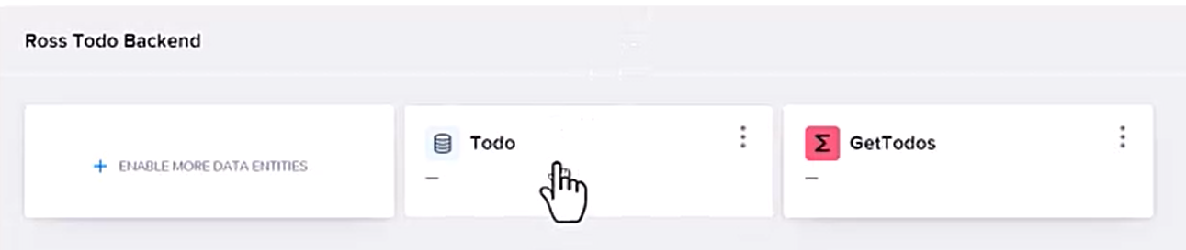

Select Cloud functions.

Select the CreateTodo function.

Click ENABLE CLOUD FUNCTION.

Click on UI CANVAS then return to the View.

To bind the Input fields to the attributes of the Data Variable, select the Input field.

Change the Label to Todo then click the x icon to the left of the Value field.

Click Data and variables.

Click Data variable.

Select the NewTodo Data variable and select todo.

Repeat for the other two Input fields to bind them to Description and Due Date.

Drag a Button control beneath the Due Date Input field.

Change the Label to Save.

To configure the logic for the Button, with the Button selected, click the black bar along the bottom of the screen.

This opens the logic pane which already has the Component tab logic component for the button.

Find the Create record component in the DATA section of the toolbox and drag it onto the canvas.

Click on the small bump on the right side of Component tab and drag and drop on the Create record component.

Select the Create record component to open its Properties.

Since we only have one Data resource, the Todo resource is already configured. We just need to configure the properties to use the Data variable we bound to the Input fields. Click the icon to the left of Custom object.

Select Data and variables.

Select Data variable.

Select the NewTodo variable.

Complete the logic as shown below.

The top port on the right of Create record is executed if the todo create is successful. The Alert will just show a static message to indicate the Todo was created successfully. The Toast will execute if there is an error. Finally, when the user clicks OK on the Alert, the app will navigate back to the list page.

The last thing we have to do is to configure a button on the My Todos page to open the New Todo page. Navigate back to the My Todos page, then drag a Button control above the list. Change the label to something like New Todo, then configure the logic as shown.

Make sure you configure the Open page component to open the New Todo page.

Launch the app. Click the New Todo button.

Enter the data and click Save.

The Todo is saved and the Alert is shown.

When you click OK, the app returns to the list page.

